## **Topic One– Tutorial**

**Chapter 1 – Basic Concepts: understanding information**

1. **Describe the types of decisions that managers are required to take. Give specific examples.**

Managers are important members of every company. Their major responsibility is to ensure that a business's operations run smoothly. To operate the organization properly, they must make a variety of decisions.

* **Strategic Decision and Routine Decision:**

Strategic decisions are the most important decisions made by the upper and middle management of a company. Management at the medium level. A firm's policies, for example.

Routine decisions are those made by the manager in the day-to-day operations of the company.

A good example is a daily work routine.

* **Programmed Decision and Non-Programmed Decision:**

Programmed decisions are ones that are generally repeated in character and are performed on a regular basis. Middle management makes these types of decisions in accordance with policies, rules, and processes. Allowing staff to take time off, purchasing office supplies, and so on.

Non-programmed decisions that are not routine or daily occurrences and are made by senior executives do not have to follow any conventional procedures.

* **Organizational decision and Personal Decision:**

Organizational decisions are made when an official makes a choice in his or her official capacity or on behalf of the organisation. Personal decisions are made when an executive makes a decision for whatever reason.

* **Individual and Group Decision:**

Individual decision refers to any decision made by an individual in an official capacity.

A Group decision is a decision made by a group of managers of an organisation or company.

* **Tactical and operational Decision:**

These decisions are made by top management and have a long-term impact on the company's operations. Decisions about the location of a facility, the volume of output, and distribution methods, as well as tactical measures, are examples of policy decisions.

Operating decisions are those that affect the day-to-day operations of a company. These choices are made by middle and lower-level managers.

Bonuses are paid to employees based on company policy. If, on the other hand, bonuses are to be awarded to employees, the calculation of bonuses for each employee is a business choice.

1. **What are the stages involved in decision making?**

A sequence of processes followed by an individual to find the best option to satisfy their needs is known as decision making. It is a collection of activities done by executives in a company to determine the planned course for business initiatives and to initiate particular measures.

Here are the steps below:

* Step 1- Identify the decision
* Step 2 -Gather relevant information
* Step 3-Identify the alternatives
* Step 4- Weigh the evidence
* Step 5- Choose among alternatives
* Step 6-Take Action
* Step 7-Review your decision and consequences.

1. **Describe the characteristics of decisions taken at different levels in an organisation.**

Decision making is the actual selection among alternatives to a course of action. It is core of

the planning. Here in the below are the characteristics of decision making at different levels in

an organisation.

* **Mental and Intellectual Process:** Decision making is a mental and intellectual process. Intelligence, knowledge, experience, educational level, and mental facilities are essential for that.
* **Decision making is a Process:** Decision making is a process to find out the solution to any problem or for the achievement of a specific result, problems are well analysed, during decision making**.**
* **Decision making** **is an Indicator of Commitment**: Decision making is the indicator of commitment because, for its implementations.
* **Decision making is a Best Selected Alternative**: Decision making is the best selected alternatives out of two or more possible alternatives for solving any problem.
* **Decision making Might be Positive or Negative:** Decision making is positive or negative. The decision of implementing any plan to do some work is positive, whereas the decision not to do any work or not to implement and plan is negative. Hence, **negative decisions are also as good decisions,** as are positive decisions.
* **Decision making is the Last Process:** Decision making is the last stage of the planning process because the result of the work is derived from it. It is the conclusion of the intellectual analysis, discussions, deliberations, comparative, and analytic study of the alternatives.
* **Decision making is a Pervasive Function:** Decision making is a pervasive function because it is used in all business and non-business organizations, for all managerial activities, all the levels of management all over the world.
* **Decision making is Continuous and Dynamic Process:** Decision making is a continuous process because decisions are to be taken continuously in the business organizations, for routine and special tasks.

**Similarly,** it is a dynamic also, because the situations and circumstances of each decision are different than the situations and circumferences of the preceding decisions.

1. **The following represents the scores, out of 10, obtained by a group of six students in a test. Produce some useful information from the data for the teacher: 4, 4, 5, 6, 8, 9.**

The **average** score for the test is **6/10,** the **highest** scored a total of **9** marks, and the **lowest** score a total of **4** marks. The most **common** score for the test was **4**. Sixty percent **(60%)** of the students were able to score half or higher marks.

1. **Describe the characteristics that will be present in information of high quality.**

Data quality is crucial. It assesses whether information can serve its purpose in a particular context. The five characteristics of high-quality information include:

* **Accuracy-Is the information correct in every details:** Accuracy is a crucial data quality characteristic because inaccurate data can cause significant problems with severe consequence.
* **Completeness-How comprehensive the information:** Completeness refers to how comprehensive the data is? If information is incomplete, it might be unusable. To send a mailing out and for that need customers last name to ensure the mail goes to the right address and without it the data is incomplete.

* **Reliability- Does the information contradict other trusted resources:** Reliability is a vital data quality characteristic. When a piece of information contradicts themselves, you cannot trust data. You could make a mistake that could cost your firm money Or reputational damage. If a patient’s birthday is January 1, 1970, in one system, June 13, 1973, in another, the information is unreliable.
* **Relevance- Do you really need this information:** Relevance matters as data quality characteristics because there must be a good reason as to why are you collecting this information? If you are gathering irrelevant information, you are wasting time as well as money. So, the analyses will be unvaluable.
* **Timeliness-How up to date is information and can it be used for real time reporting:** Timeliness of information is an important data quality characteristic because information that is not timely can lead to making wrong decisions which costs organizations time, money, and reputational damage.

1. **How the value of information can be determined?**

* **Value of information** is a most important asset in an organization. Followings are the criteria which is important to determine value of information:
* **Accuracy-** Information should be precise and close to reality and free from bias or any errors.
* **Consistency-** Information should be free of contradictions.
* **Applicability-** Information should be able to be applied directly.
* **Clarity**- Information should be well, understandable and clearly presented.
* **Comprehensiveness-** Information should be adequate which is not too much or too little.
* **Currency**- Information should be up to date.
* **Convenience-**Information should be comparable to the user's needs.
* **Traceability-** Background of the information should be traceable, such as the used data,

authors.

* **Accessibility**- Information should be continuously accessible without too many obstructions.

1. **What are the differences between formal and informal information? Give examples of each that you encounter in your university and work routines.**

* **Formal Information:** A formal information is based on an organization represented by organization chart and which is useful as it works within the framework of the organization and its stated policies.
* **Informal Information:** The information which may be indirectly incorporated into an official system, reflected primarily as adjustments and modified to a formal information.
* **Difference between formal and informal information:**

|  |  |
| --- | --- |
| **Formal Information** | **Informal Information** |
| * Formal information's are constituted in some regularized or legal manner in relation to the user's needs**.** | * Informal information's have no such basis. |
| * Formal information can be stored and * easily retrieved. | * Informal information often will be lost in a short time. |
| * Formal information is in principle easy to * survey and check. | * Informal information could be difficult in this respect. |
| * Formal information is often not very * concentrated. | * Informal information is often more concentrated. |
| * Formal information can in principle be disseminated in an unlimited way. | * Informal information is by nature often exclusive. |

1. **Explain how the concept of knowledge management relates to data and information.**

* **Data:** The raw material of information with no content and are incoherent facts and observations that could easily be converted to information when sorted, analysed and organized.

* **Information:** Information is data that has been processed into meaningful form which collected with context, analysis, and interpretation and can be represented as facts, figures, statements, and statistics etc.
* **Knowledge:** Knowledge is information that has been analysed, reflected upon, and synthesized. It is a mixture of values, information.
* **Knowledge management:** It is a formal process used to determine the information a company has that is beneficial to others and making it easily available to those who need it**.**
* **The relationship between data, information and knowledge:** The relationship between data, information and knowledge is strong. In order for data and information to be interpretable, knowledge is required. Data and information are primarily useful in the creation of new knowledge. Data also known as unprocessed information, when used in the right context becomes information. Knowledge is the incorporation of information, data, and experience.

**End of Tutorial One**

## **TUTORIAL 2**

**Chapter 2 – Acquiring BIS and SDLC**

**1.What is the Difference between an ‘INFORMATION SYSTEM’ and ‘INFORMATION TECHNOLOGY’?**

* **Information System:** Information system is a formal, sociotechnical, organizational system designed to collect, process, store and distribute information to help coordination, visualization in an organization analysis and decision making.
* **Information technology:** Information technology is the use of computer to create, process, store, retrieve and exchange all kinds of electronics data and information.
* Information system and information technology are often used interchangeably but, these are different.
* **The differences between these two:**

|  |  |
| --- | --- |
| **Information System** | **Information technology** |
| * It is a software used to organize and analyze data | * It is a sub system of information system |
| * It mainly focuses on providing support to operations, management, and decision-making. | * It mainly focuses on improving productivity and efficiency using technology. |
| * It works as a bridge between technology and people. | * It helps people to utilize and make sense of that system. |
| * It includes how people and processes can support or hinder the performance of their organization, managing computer networks and applications within modern business environments. | * It includes rolling out new software updates, troubleshooting problems of the user’s technology, replacing outdated hardware, etc., to meet operational demands. |

**2.Draw a diagram illustrating the main components of a generic system.**



**<<Gesture analysis>>**

**<< Robot interface>>**

**r**

**<<Behavior and intention recognition>>**

**<<Sequence learning and imitation>>**

**<<Failure detects and recovery>>**

**<<Emotion and face recognition>>**

**<<Cognitive learning>>**

**<<Safe manipulator arm>>**

**<<Main Application>>**



3. **Information systems play a critical part in supporting a company’s activities. Using specific examples**

**a. Define an information system**

* **Information system:** An information system is a group of components that interact to produce information. It is an integrated and coopering set of software directed information technologies supporting individual, group, organisational or social goal. It is the study of complementary networks that people and organisations use to collect, filter, process, create and distribute data.

**b. Describe the categories of computer-based information systems, providing relevant examples for each category identified.**

* **Computer based Information Systems (CBIS):** There are different types of information systems. Computer based information system is one of them to meet variety of business or organization needs. Computer based information systems are categories as:
* **Transaction Processing System (TPS):** This is the most fundamental computer-based system to process business transactions. This system is aimed at improving the routine business activities like placing order, billing customers and hiring of employees. This system provides speed and accuracy and can be programmed to follow routine without any variance.
* **Management Information System (MIS):** These systems make use of information technology to help managers ensure a smooth and efficient running of the organization. Information collected by these systems is structured so that the managers can easily evaluate the company’s current performance and previous outputs. Some of the common types of Management Information Systems include process control systems, human resource management systems, sales and marketing systems, inventory control systems, office automation systems, enterprise resource planning systems, accounting and finance systems and management reporting systems.
* **Decision Support System (DSS):**  It is an information system that offers the kind of information that may not be predictable. Business professionals may need such information only once. These systems do not produce regularly scheduled management reports. Instead, they are designed to respond to wide range of requests. It is true that all the decisions in an organization are not of a recurring nature. Decision support systems assist managers, who make decisions that are not highly structured, often called unstructured or semi structured decision. The decision support systems support, but do not replace, judgments of managers.
* **Office Automation System (OAS):** Office Automation Systems are among the newest and most rapidly expanding computer-based information systems. They are being developed with the hope and expectation that they will increase the efficiency and productivity of office workers, typists, secretaries, administrative assistants, staff professionals, managers, and others.

**C. Explain how computer-based information systems can support managers at each level of an organisation.**

* **Computer based information systems** are very important in the day-to-day support managers at each level of their organisation. Information systems helps managers to achieve high level of efficiency in an organisations management operation. Information collected by these systems is structured so that the managers can easily evaluate the organisations current performance and as well as previous outputs. Information systems helps managers to planning, controlling and decision making. Information systems helps managers to produce and view reports regularly.

4**. Explain the terms ‘bespoke development’, ‘off-the-shelf package’ and ‘end user computing’. Illustrate your answer with some of the reasons cited in favour of each of these methods of application software acquisition**.

* **Bespoke Software Development:** Bespoke software development is essentially and development that is implemented for a specific, unique purpose. It is more flexible which can evolve over time to match your changing requirements. If you own the software, you will not have to extra per-fees as your business grows and you are not tied to any specific vendor that could potentially disappear at any time.

* **Off-the-shelf package** Off-the-shelf software is a software that is ready –made and available to lots of people to use it. Usually pay a license fee to use it. E.g., Microsoft Office. It is cheaper as the development costs are spread across many users and immediate available because the development work has already been done. The upgrades are free or at a reduced cost, so users can easily get support and advice by using books, articles to meet their requirements.
* **End user computing:** End user computing encompasses user to enterprise applications and data anywhere, anytime, using one or more devices to access virtual desktop infrastructure located either at the enterprise's premises or in public cloud. It provides support for a broad range of client devices including traditional PC, tablet, smartphone, or thin-client terminal device.

**5.What is SDLC?**

**SDLC** is **Software Development Life Cycle.** It is a systematic process for building software that ensures the quality and correctness of the software built.

**a. What are the different stages of SDLC?**

There are seven stages of SDLC.

A brief breakdown is:

* Planning Stage
* Feasibility or Requirements of Analysis Stage
* Design and prototyping Stage
* Coding or Software Development Stage
* Software Testing Stage
* Software Deployment Stage
* Operations and Maintenance stage

**b. Explain each stage identified in “a”.**

* **Explaining each stage individually:**
* **Planning stage:** In this stage, we are putting together all the tools to consider the scope and gravitas needed to pursue the software or project we want.
* **Feasibility or Requirements of Analysis Stage:** In this stage, we are putting together all the tools to consider the scop and gravitas need needed to pursue the software or project we want.
* **Design and prototyping Stage:** Developers and software architects start designing the software after they have identified requirements. Developers apply proven methods for developing software to solve algorithmic issues.
* **Coding or Software Development Stage:** Tasks are divided into units or modules in the coding process and allocated to specific developers.
* **Software Testing Stage:** When the coding is complete, testing begins, and the modules are released for evaluation as software testing is necessary to avoid any bug.
* **Software Deployment Stage:** In this stage, we are putting together all the tools to consider the scop and gravitas needed to pursue the software or project we want.
* **Operations and Maintenance stage:** When the software passes through all the stages without any complication a maintenance cycle is to be performed in which it is updated and modified from time to time to adapt to changes.

**Practical questions (Discuss in groups of 2)**

**1.A small company is considering the purchase of a computer and accounting software to help it keep track of its finance. In general, what are the benefits of processing by computer? What other benefits might the company gain in taking this step?**

Advantages of right software in businessis very helpful as it cut costs by automating routine tasks. It improves the efficiency of staff and increase office productivity.

* **Benefits of using computer software:**
* **Improved Efficiency-**The incredible speed in which business computer soft-ware can perform tasks that were once manually does by hand has allowed a business to become more efficient and focus on other important areas of the business.
* **Improved Customer Services-**It is easy to keep the information in an organized and secure digital format by using computer software. It is very helpful to build and maintain a strong customer relation based on their likes and dislikes.
* **Better Management of the Business-** Management is better able to control nearly every aspect of their business. With fully integrated computer software managers can monitor all departments in real time. They can do multitask such as checking sales reports, business expenses etc as well as are able to deliver services with increased speed and accuracy.
* **Benefits of using accounting software:**
* **Saving time-** A quality accounting software system can really help to save a lot of time compared to manual bookkeeping.
* **Continuous financial monitoring-** Computerized bookkeeping helps to create and maintain financial records continuously which enables company management to monitor and resolves any issue arrives.
* **Minimizes mistakes-** Accounting software performs all the calculation automatically and accurately which minimizes mistakes.
* **Computerised Invoicing-** With accounting software can get up to date reports on customer payments which can provide details on customers owing and the amount to be paid.
* **Neat and Tidy Organization-** Using accounting software data and information can store securely in a single location and it helps to review, reprint, and resend if needed anytime.
* **Track’s inventory-** Using accounting software many quality solutions can track product inventory and provide up to date details on the amount of stock in hand which can provide accurate data and help to save time too.
* **Actionable Reports-** Accounting system can provide detailed reports on business process and help to track the money flow, help to get a clear picture of costs, profits, and revenue at any time, which can help to make smart decision operation business more efficiently and productively.

There are many more benefits of using computer and account software which taking businesses into future and making them more competitive, and software’s become valuable business asset.

**2.Consider that university is having problem with analysing data with the existing system and have asked you to conduct some research in terms of replacing/acquiring the existing system. Based on the research you carried out fill in the table below:**

|  |  |  |  |  |  |
| --- | --- | --- | --- | --- | --- |
| **1.00 General Information: Answered?** | | | | | **Action** |
| **Question** | | **Yes** | **No** | **N/A** | **Comments / Response** |
| 1.01 | What problem is being solved or what business/educational need is being filled by this particular software acquisition? Please be as specific as possible. |  |  |  | The problem is an engineer updated the system then contains malware accidentally. So in this case, we know we must uninstall then reinstall the Microsoft windows to access program. |
| 1.02 | Who will use the software? Will it be limited to one user, a few users, one or more departments or courses, faculty, staff, students, the campus, the general public? Is it possible that a larger need for this software exists on campus? Estimate the number and types of users. |  |  |  | The people that benefit from this update of software access are the students, admin workers of the university and our tutors. However, if statistics are needed by outside companies, then the university can use that software to with a link for external uses to access. |
| 1.03 | Is the proposed software off-the-shelf, bespoke or user developed? |  |  |  | Off-the shelf |
| 1.04 | Have you conducted a basic review of similar applications and/or services to ensure an alternative product does not exist that would better meet your needs? If yes, list the names of the alternative products or services that have been considered. |  |  |  | We considered google drive could have been used but it is a programme which is not part of Microsoft which the university uses to communicate with all users even though some match can be merged from and with google and Microsoft. It would be more efficient and compatible to use Microsoft offices programme. |

**End of Tutorial Two**

**Tutorial Three**

**Software Development Methodology.**

**1) What is the difference between Waterfall and Agile Software development lifecycle? Explain each stage briefly.**

* **Waterfall software development lifecycle:**

Waterfall methodology called the linear-sequential life cycle as well. It is a kind of model that breaks down project activities into systematics linear sequence.

* **The stages of Waterfall software development life cycle are as follows:**
* Requirements
* Analysis
* Design
* Coding
* Testing
* deployment
* **Agile software development lifecycle:**

It is the combination of both iterative and incremental process models which focuses on process adaptability and customer satisfaction by rapid delivery of working software product.

* **The stages of Agile software development lifecycle are the following:**
* Requirements
* Design
* Development and coding
* Integration and testing
* Implementation and deployment
* **Waterfall and Agile methodologies are the most popular methods. Here is the differences between them:**

|  |  |
| --- | --- |
| **Waterfall** | **Agile** |
| * Software development process is divided into distinct phases. | * It separates the project development lifecycle into sprints. |
| * It is a sequential design process. | * It follows an incremental approach |
| * It is a structured software development methodology, so most times it can be quite rigid. | * It is a flexible methodology. |
| * Software development will be complete as one single project | * It can be considered as a collection of many different project. |
| * There is no scope of changing the requirements once the project development starts. | * It allows changes to be made as it is a flexible method. |

**2) In what circumstance do you think that SSADM would be**

* **SSADM-** is **Structured Systems Analysis & Design Method** which is a widely used computer application development method in the UK. It is increasingly being adopted by the public sector in Europe. SSADM is in the public domain and is formally specified in British Standard BS7738.
* **appropriate:**

SSADM divides an application development project into modules, stages, steps, and tasks, and provides a framework for describing projects in a fashion suited to managing the project. SSADM is suitable for the system development process where the requirements of the project are not known, and the project is big in category. SSADM is data driven high structure with very detailed rules and guidelines which adhered the big project into small. It is also suitable for the big project that requires data modelling and cross referencing for consistency.

* **Inappropriate:**

SSADM is not appropriate for online airlines ticketing system development process. Because it is normal project, and it is a group work so that human resources and time are bottleneck for SSDAM which making it inappropriate for projects of a small nature. It does not require the procedural and huge documentation of SSDAM.

**3) Define Agile software development and list five characteristics.**

* **Agile Software Development:**

It is the combination of both iterative and incremental process models which focuses on process adaptability and customer satisfaction by rapid delivery of working software product.

* **Agile software development has five characteristics below:**
* Customer Satisfaction
* Fast Delivery Times
* Continuous Adaption
* Focus on Collaboration
* Greater Transparency

**4) How can Agile methodologies be categorised? list five methodologies under each category.**

Agile methodology can be categorised in Fuller**,** more extensive methods and Light weight approaches methodology.

* **Light weight approaches methodology are as follows:**
* Scrum
* Lean
* Kanban
* Crystal
* Extreme Programming
* **Fuller, more extensive methods are as follows:**
* Dynamic System Development Method (DSMD)
* Agile Unified Process (AUP)
* Feature Driven Development (FDP)
* Scaled Agile framework (SAFe)
* 5. Project Focused (non-IT)

**5) Explain Kanban and Scrum.**

* **Kanban Methodology:** The Kanban method is to design and improve flow system for knowledge work which allows organization to start their existing workflow and drive evolutionary change. They can do this by visualizing their flow of work, limit work in progress and stop starting and start finishing.
* **Scrum Methodology:** Scrum is an agile development methodology used in the development of software based on an iterative and incremental process. It is adaptable, fast, flexible and effective agile framework that is designed to deliver value to the customer throughout the development of the project. The primary objective of scrum is to satisfy the customers need through an environment of transparency in communication, collective responsibility, and continuous process.

**6) Compare and contrast two most widely used Agile methodologies and give justification of your answer.**

Agile methodology is an umbrella term for any set of frameworks and practices that involve building and launching software in incremental phases. The two most popular methodology is scrum and Kanban.

An overview of each which will help to decide the best framework.

* **Scrum:** The scrum framework is the most widely used of the agile development frameworks and is designed to deliver value to the customer throughout the development of the project. Scrum is ideal for software development agencies who build software for their clients. The frequent demos and check points that come with operating in sprints ensures that teams and clients are always on the same page.
* **Kanban:** Kanban is a visual-based agile framework with a focus on optimizing the flow of work in a continuous delivery manner. Kanban is ideal for organizations that to incorporate the benefits of agile but are not willing to make very drastic changes to their workflow. It is also suited for projects in which priorities change on the fly, and ad hoc tasks can happen anytime.

While this is a comparison between the Scrum and Kanban frameworks of the agile software development methodology, it should be understandable that no one method is better than the other. Each has its pros and cons, and sometimes they even complement one another. Individual must discover what works for their team and flex the system accordingly.

**7a) In pairs of 2 (coursework members) and get yourself familiarised with the scrum board at**  [**http://scrumblr.coop-tic.eu/**](http://scrumblr.coop-tic.eu/)

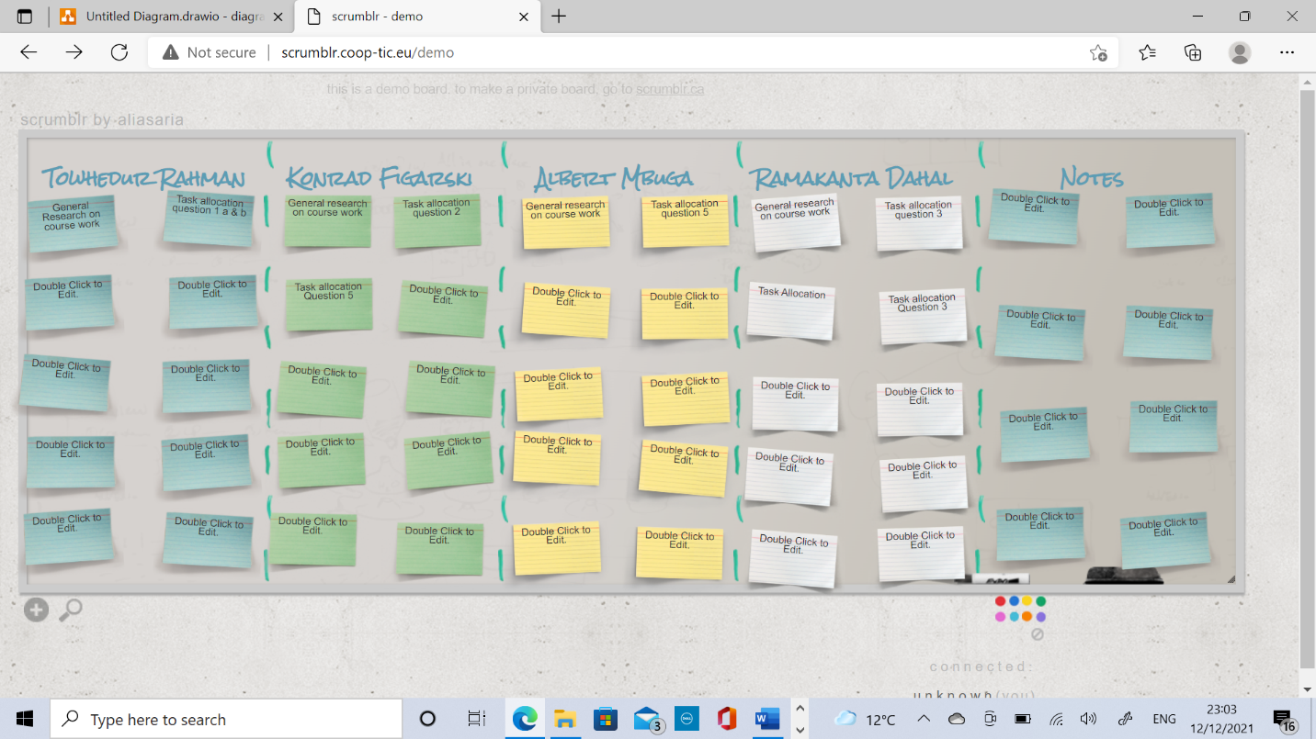

**7b) Using the Scrum example below create a simple Scrum task board at** [**http://scrumblr.coop-tic.eu/**](http://scrumblr.coop-tic.eu/) **for your CN4000 assignment. Once you have created your board compare it with your other two members. You can also use this in your assignment.**

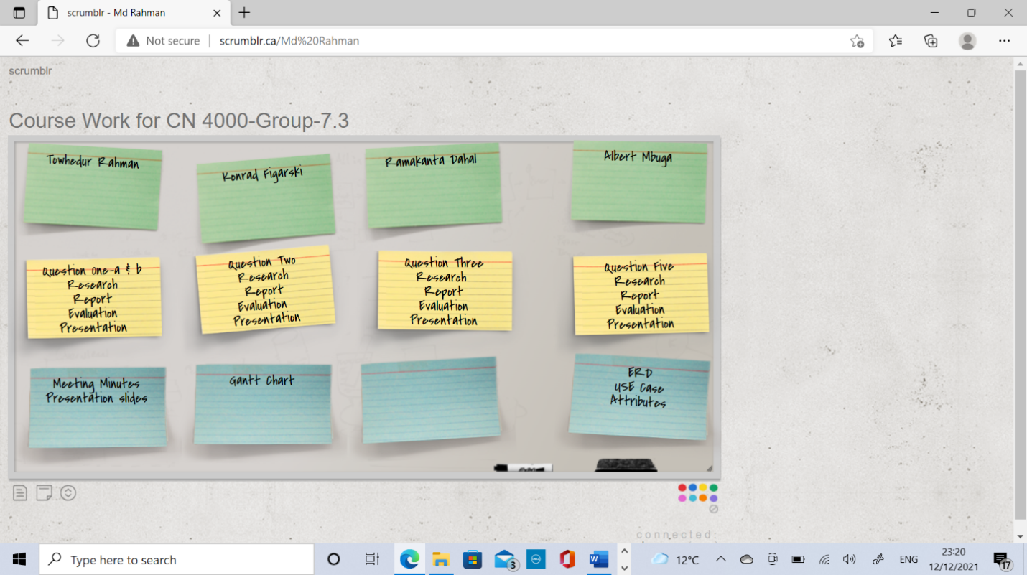

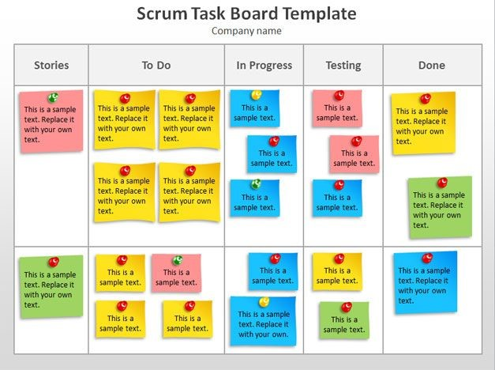

**End Tutorial Three**

**Tutorial Four**

**Chapter 8**

**Initiating systems development and Project Management**

The following are examples of costs and benefits:

* Software purchase cost
* User resistance
* Reduction in working hours
* Improved decision making
* Hardware purchase cost
* New working practices
* Sales increase
* Broader planning horizons
* Implementing costs
* Disruption during implementation
* Training costs
* Reduction in customer complaints
* Better data integration
* Reduction unmaintainable costs
* Better data quality
* Hardware and software maintenance and consumable costs
* Reduction in inventory levels
* Better cash flow

**Q. Assess where they should be in the grid below:**

|  |  |  |  |
| --- | --- | --- | --- |
| **Costs** | | **Benefits** | |
| **Tangible** | **Intangible** | **Tangible** | **Intangible** |
| * Software purchase cost | * User Resistance | * Reduction in working hours | * Improved decision making |
| * Hardware purchase cost | * Disruption during Implementation | * Sales increase | * New working practices |
| * Training cost |  | * Reduction customer complaints | * Broader planning horizons |
| * Hardware and Software |  | * Reduction unmaintainable cost | * Better data quality |
|  |  | * Reduction inventory levels |  |
|  |  |  |  |

**2.What is the purpose of the initiation phase of a project?**

* **Purpose of the initiation phase of a project:** The project initiation phase holds great value since it involves hiring a project team and setting solid goals. Without an efficient project team and clear goals, it gets difficult to perform the required duties throughout the project cycle.

**3.Summarise the differences between economic, operational, technical, and organisational feasibility.**

* **Economic Feasibility:** Economic feasibility analysis is the most used method for **determining the efficiency of a new project.** It is also known as cost analysis. It helps in identifying profit against investment expected from a project. Cost and time are the most essential factors involved in this field of study.
* **Operational Feasibility:** Operational feasibility entails **utilizing, supporting, and performing necessary program, system, or project tasks**. It includes everyone that creates or operates a system. For a project or system to be ascertain operationally feasible, it must meet specific criteria.
* **Technical Feasibility:** Technical feasibility is the formal process of**assessing whether it is technically possible to manufacture a product or service.** Before launching a new offering or taking up a client project, it is essential to plan and prepare for every step of the operation.
* **Organisational Feasibility:**

Organizational feasibility involves a company's ability to handle an undertaking. What determines organizational feasibility includes the management team's set of skills, competency, and available resources to successfully launch its business.

**4.What do you understand by the term ‘risk assessment’ and how can it be applied to assist an information systems development project?**

* **Risk assessment**: Risk assessment is the process of determining risks that could potentially prevent the program, enterprise, or investment from achieving its objectives.
* Risk assessment is a term used to describe the overall process or method where can Identify hazards and risk factors that have the potential to cause harm.
* **How can risk assessment be applied to assist an information systems development project:**
* Identify the list of every possible risk may cause harm.
* Determine the probability of who may be harmed and how much it will be?
* Asses the risks and act to resolve it.
* Make a record of findings and establish a risk management process.
* Continuously review the risk.

**5.What are** **the key factors that a company will consider when choosing software from different suppliers?**

The key factors that a company will consider when choosing software from different suppliers are as follows:

* How much does it cost and what is the value?
* Will you need assisted implementation?
* Is the software company prepare to fix bugs?
* How often do they push updates?
* Is the system customizable enough to meet your needs?
* What kind of support do they offer?
* What kind of security does the software provide?

**6.What are the main items that should be specified in an information system contract?**

Contracts are the backbone of any relationship and a document which holds a legal recognition and in case of breach or fraud and saves a person from losing money or property. They are the face of trust and sense of surety as they minimize the probability of the risk.

There are six elements of contracts that are essential. They are-

* Offer
* Acceptance
* Consideration
* Mutuality of Obligation
* Competency
* Capacity

**Getting familiar with an Information System**

**Microsoft Access - Exercise**

Follow the directions below to create an Address Database. Remember that there is usually more than one way to do something. If you think of a different way to do a task, try it! If it doesn't work, you can always use the Undo button. Please read through each direction before performing the action.

## **Starting Access**

1. Launch the Access program by double clicking on the Access icon under Office365. A Microsoft Access window will appear. If you do not see access under office 365 then please use you’re the “Software Centre” on your UEL desktop and search for “Microsoft Access” and install.
2. Click “***New”*** on the file menu or click the new file icon on the toolbar.
3. In the pane on the right side, click ***Blank database***.
4. The File New Database Window will appear.
5. Type the file name **Address Book**.
6. Save it at your desired location
7. Click Create.

## **Creating a Table**

1. Click the ***Tables*** tab in the database window.
2. Click ***New***.
3. The New Table Wizard appears.
4. Select ***Table Wizard*** and click ***OK*.**
5. Select the Personaltoggle located above the Sample Tables column. Select ***Addresses*** from the Sample Tables column (left click once to highlight.)
6. Select ***FirstName***from the Sample Fields column (click once to highlight the selection.) Click the right pointing arrow button or double click the selection to add it to the Fields in My New Table column.
7. Repeat step #6 with ***Last Name****,* ***Address****,* ***City****,* ***County****,* ***Postal Code****,* and***Home Phone Number*** from the Sample Fields column.
8. Click ***Next***.
9. The Table Wizard offers the name “Addresses” for your table; we’ll keep that name. (On this same screen, there is a "YES" default for setting a Primary Key). Click ***Next***.
10. Click ***Finish*** and view your new table.
11. Close the “Addresses” table (Click the X in the top right corner of the table window.)

**25/10/21-31/10/21**

## **Week -5, TUTORIAL 5**

**System Analysis part 1**

1. **Assess the relative effectiveness of interview versus questionnaires when attempting to establish user requirements.**

* **The relative effectiveness of interview versus questionaries:**
* **Interview:** Interviews involve direct verbal questioning of participants by the researcher. This technique can obtain private aspects of behavior and collect detailed qualitative data about sensitive issues. They are relatively easy to replicate if structured interviews are used e.g., all interviewees are asked the same questions. However, if unstructured interviews are used exploring a general topic in depth which can uncover additional information that you didn’t plan on obtaining makes interviews very difficult to replicate.

During interviews, the researcher can expand and clarify the question if the participant does not understand, but on the other hand the researcher may cause problems e.g. investigator effects where the participants may find the investigator attractive and therefore make themselves sound better which causes false information to be gathered. The interviewer himself may have a bias towards some people and may interpret the behaviors of some participants as meaning one thing when it means something else.

* **Questionnaire:** A questionnaire is used to collect information from a large sample of people about their views, attitudes, and behaviours. It can be used to gather data on a wide variety of topics and once constructed they are easy to administer, large amounts of data can be gathered quickly and relatively cheaply and both quantitative and qualitative data can be produced from them.

However, you cannot be sure that respondents will answer questions truthfully as they may not want people knowing about a certain situation e.g. a drinking problem. Respondents may also interpret questions differently therefore giving unreliable information or they may answer questions in a way that they think the researcher wants (demand characteristics) and usually very few of the people given the questionnaires fill them in and return them.

As both the methods have their pros and cons, it cannot be said which method is best, i.e. while questionnaire method takes more time, interview method requires high investment.

1. **Explain the relationship between the initiation and analysis phases of the system development lifecycle.**

* **Relationship between initiative phase and analysis phase:**

The project initiation phase is the first phase within the project management life cycle, as it involves starting up a new project. Within the initiation phase, the business problem or opportunity is identified, a solution is defined, a project is formed, and a project team is appointed to build and deliver the solution to the customer. A business case is created to define the problem or opportunity in detail and identify a preferred solution for implementation.

The Analysis phase is also the part of the project where you identify the overall direction that the project will take through the creation of the project strategy documents. Gathering requirements is the main attraction of the Analysis Phase.

1. **What is Data Modelling?**

* **Data Modeling:**

Data Modelling is the process of creating data models by which data associations and constraints are described and eventually coded to reuse. It conceptually represents data with diagrams, symbols, or text to visualize the interrelation. Data Modelling thus helps to increase consistency in naming, rules, semantics, and security.

1. **Explain the purpose of each of the following diagramming methods:**

* **Purpose of information flow diagram:**

The main purpose of an information flow diagram is so that sources that send and receive information can be displayed neatly and analyzed, and which allows viewers to see the forwarding of information and the analysis of different situations.

* **Purpose of context diagram:**

The context diagram is used to establish the context and boundaries of the system to be modelled into which is inside and outside of the system. It identifies the flows of information between the system and external entities.

* **Purpose of dataflow diagram:**

Dataflow diagrams are used to show users how data moves between different processes in a system. It follows a hierarchy; that is, a diagram may consist of several layers, each unique to a specific process or data function.

* **Purpose of entity relationship diagram:**

An entity relationship diagram gives a snapshot of how these entities relate to each other. Entity relationship is crucial to creating a good database design. It is used as a high-level logical data model which id useful in developing a conceptual design for database.

1. **Name the three types of degrees of relationships.**

**Answer:**

Husband--------------One to One-------------Wife

Football Team---------One=to-Many<-------Football

Student----------------->Many to Many<------Subject

1. Explain cardinality and optionality.

* **Cardinality:**

Cardinality is a mathematical term which translates into the number of elements in a set and refers to the relationship between the data in two database tables. It defines how many instances of one entity are related to instances of another entity.

A doctor can have one or many consultations on a given day. So, the relationship between the doctor entity and the consult entity are one doctor to many consults means it is a one-to-many relationship**.**

* **Optionality:**

Optionality is related within the cardinality.Optionality is defined as something that has more than one good solution for a complex challenge. Therefore, a software product that includes optionality would quickly enable the creation of new solutions to respond to changing business requirements.

1. **Create your project plan (in a group) using Project 365 on your desktop “Software Centre”**

## **Topic 6 Tutorial**

## **Using** [**www.draw.io**](http://www.draw.io) **answer the following:**

**Q1. For the case-study design of Cinema, design the full (Advance) E-R diagram that shows the link between them and list all the attributes along with PK and FK.**

Cinema booking system. The cinema needs to have tables that record films, showtimes, and sales. The cinema does not need to record its customers’ details; this is not required when you buy your cinema ticket. But there may be other data that need to store other than those three tables. Can you guess them from the E-R diagram?

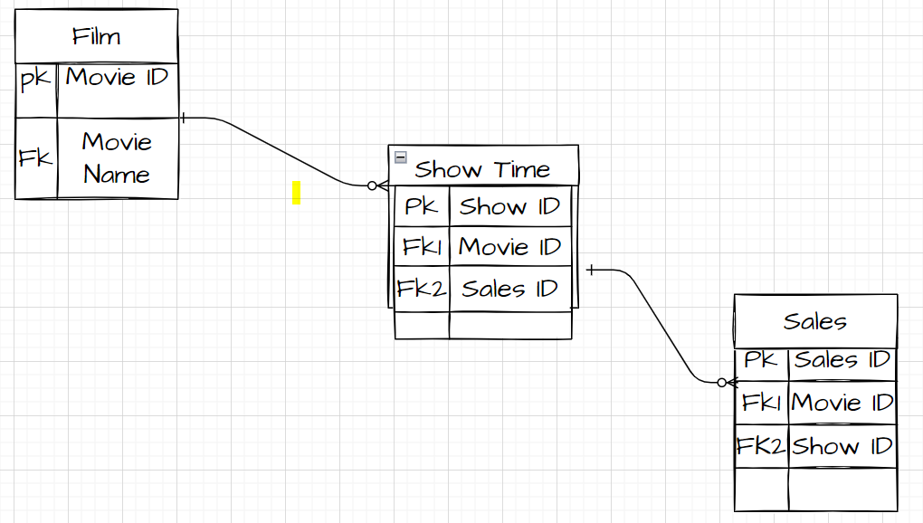

**Q2. Draw a DFD for the following case.**

**Tap on Attendance System:**

A university is considering an ID tap on attendance system. The Teacher sets the system at the start of the session by selecting the session details. Students tap their IDs. Everything is recorded in the Student Attendance Database. At the end of the day, Student Affairs runs an attendance check on the Student attendance Database. The system would then automatically email students who missed classes an email warning and flag those students who have now exceeded their limit. Student Affairs would contact the students by email to let student know they have been removed from the course with email copy to the tutor.

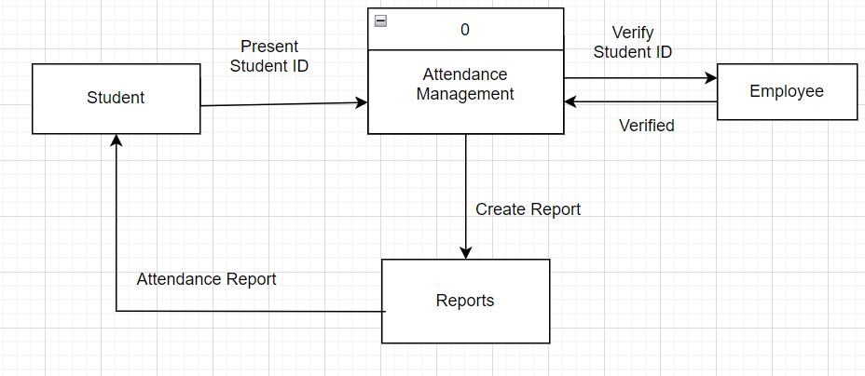

**Q3. Can you spot the mistake in the following DFD**

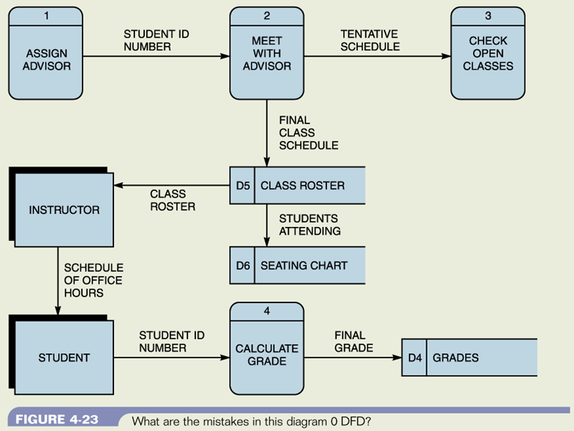

**End Tutorial Six**

**Topic 7 – Tutorial**

**Chapter 4 - Software**

1. Define database and highlight the major advantages.

* **Database:** It is a data structure that stores organized information or data electronically in computer system which controlled by a management system and can be easily accessed, updated and modified, controlled and organized.
* **Major advantages of database:**
* **Multi-user’s access**-Multi-users can connect and make changes to the same database. Example- database of airline reservation system and banking database.
* **Distributed access-** It allow local users to manage and access the data in the local database while providing some sort of global data management which provides global users with a global view of the data. Example- Amazon Simple database.
* **Speed-** It improves the accessibility of data and makes it simpler for user.
* **Data quality**- Easily processed and analyzed for users to better decision making.
* **Security-** It safeguard valuable information from unwanted individuals.
* **Space efficiency-**It allow users to storage, filtering and lead to the desired outcomes.

1. Produce your own definitions of the following terms:
2. **Software:** A collection of instructions, data, or programs to operate a computer and execute specific tasks which developed by a computer programmer is software. Examples- Windows, Linux, Google Chrome etc.
3. **Operating System:** It is a software that interacts with the hardware of the computer in order to manage and direct the computers resources.
4. **Graphical User Interface:** The graphical user interface is a form of user interface that allows users to interact with electronic devices via visual indicator representations.Example- Microsoft operating system.
5. **Database types:** are as follows:

* **Flat file database-** It is a simple database which stored in a file with just one table can be created in spreadsheet or in a database software.
* **Free-form database**- It is a database system which allows entry of unstructured text without regard to length or order. Example- Access, Oracle database.
* **Hypertext database-** It is a special type of database system and objects like text, pictures etc. are linked to each other.
* **Relational database management system (RDBMS)-** It is program that allow users to create, update and administer a relational database Example- Oracle, Microsoft SQL server database.

1. **Primary Key:** A primary key is a column or a set of columns in a database table whose values uniquely identify a row in the table.
2. **Foreign Key:** A **foreign key** is a column or group of columns in a relational database table that provides a link between data in two tables which refers to the primary key in one of the tables.
3. **SQL:** It is **Structured Query Language** which designed for extracting and organizing data stored in relational database.
4. **What is Business intelligence explaining with examples?**

* **Business Intelligence:** A set of processes, architectures, and technologies that convert raw data into meaningful information that enable organizations to make better decision and implement more efficient business processes.
* **Data Warehouse**: A data warehouse stores company information from a variety of sources in a centralized and accessible location. Data analytics tools mine and analyses data in the warehouse. Business performance management tools monitor and analyses progress towards business goals. A user interface provides quick access the information.

Artificial intelligence is an example of business intelligence. Artificial intelligence and machine learning emulate complex tasks executed by human brains. This capability drives real-time data analysis and dashboard reporting.

**4, Q Explain using data warehousing:**

A data warehouse is a system that stores data from a company’s operational databases as external sources.

It is an increasingly important business intelligence tool, allowing organization to-

* **Ensure consistency**-data warehouses are programmed to apply a uniform format to all collected data, which makes it easier for corporate decision maker to analyze and share data insights with their colleagues around the globe.
* **Make better business decision**: Successful business leaders develop data-driven strategies and rarely make decisions without consulting the facts. Data warehousing improves the speed and efficiency of accessing different data sets and makes it easier for corporate decision makers to derive insights that guide the business and marketing strategies that set them apart from their competitors.
* **Improve their bottom-line:** Data warehouse platforms allow business leaders to quickly access their organizational historical activities and evaluate initiatives that have been successful or unsuccessful in the past. This allows executives to see where they can adjust their strategy to decrease cost, maximize efficiency and increase sales to improve their bottom line.

1. **Q. What is data mining:**

Data mining is a process that uses statistical, mathematical, artificial intelligence and other techniques to extract useful information from large databases.

**How can it bring benefits to a business organization:**

There are many benefits of data mining, including some specific ones that add value to business:

* **Optimize marketing campaign:** Data mining helps businesses understand which marketing campaigns will likely generate the most engagement. Classify customers, display personalized advertisements, and optimize marketing spend.
* **Detect possible fraud:** Data mining helps businesses detect fraudulent activity and anticipate potential fraud, for example, analysis of point of sale (POS).
* **Make better business decisions:** Rather than solely relying on your intuition or experience, insights generated from your own business data can help you make better decisions.
* **Insight into employees and HR policies:** Data mining not only helps improve external market performance but can also be used to understand employee behavior, predict attrition, and evaluate HR policies.

1. **Describe the (each)**

* **File processing:**

It is the process of creating, sorting, and accessing content of files. File processing can be used in opening saved files for read only. It can be used to save a new file or displace the existing one. You can modify files through this process.

* **Different approaches to file processing:**
* Relative-record-number processing.
* Consecutive processing.
* Sequential-by-key processing.
* Random-by-key processing.
* Sequential-within-limits processing.
* **Major characteristics of file processing approaches:**

Here is the list of some **important** characteristics of file processing system:

• It is a group of files storing data of an organization.

• Each file is independent from one another.

• Each file is called a flat file.

• Each file contained and processed information for one specific function, such as accounting or inventory.

* **Advantages of file processing approaches:**
* **Cost friendly** – There is a very minimal to no set up and usage fee for File Processing System. (In most cases, free tools are inbuilt in computers.)
* **Easy to use** – File systems require very basic learning and understanding, hence, can be easily used.
* **High scalability** – One can very easily switch from smaller to larger files as per his needs.
* **Disadvantages of file processing approaches:**
* Inconsistency. In file processing system, various copies of same data may contain different values.
* Accessing Anomalies. Accessing anomalies means that it is not easy to access data in a desired or efficient way. It makes supervision of department very difficult.
* Atomicity Problem. Atomicity is required to save the data values; it means that information is completely entered or cancelled at all.
* Wastage of Labour and Space. Labour is very costly in this era and no organization can afford wastage of their precious labour.
* Data Isolation. Data is isolated in File Processing System and data is stored in different files. These files can be in different formats.

1. **Define MS Access as per your understanding of working with it in last two weeks?**

* **MS Access:** MS Access is a database management system that businesses can use to store and manage large amount of data.
  1. **Highlight the advantages and disadvantages of MS Access:**
* **Advantages of MS Access:**
* It is the most popular database system in the world.
* It is easy to install and use.
* It is cost-effective.
* Easy to share data.
* It provides an extensive quantity of storage space.
* **Disadvantages of MS Access:**
* It is a finite data base system
* All data is saved into a single file.
* Multimedia data is difficult to incorporate.
* Time critical transactions are difficult to capture
* Multiple windows operating system can corrupt database.

**B)Major differences between MS Access and MS Excel:**

|  |  |
| --- | --- |
| **MS Access** | **MS Excel** |
| * Access is the management system that deals with the management and storage of detailed data | * Excel is the spreadsheet program that helps in analysis and calculate complex numerical data with the help of significant formulas. |
| * Data storage capacity is higher than excel. It can manage data at the macro level. | * Data storing capacity is limited. It can not manage data on a large scale. |
| * It is a data storage system and used in organizations and businesses. | * It analysis numerical data easily and used by financial analysts. |
| * It is complex to use because of its macro-level operations. | * It is comparatively easier to use because of its compiling and analyzing techniques. |
| * It comprises of charts, tables, graphs and pivot tables. | * It comprises of forms, reports, queries, and tables. |

**C) Can both be classified as the information systems? Justify.**

MS Excel and MS Access are two of the most powerful tools of Microsoft which are used for data analysis and report generation purpose. Excel is an old product of Microsoft whereas access is the newest advanced and complex product of Microsoft, excel is very easy to create dashboard and formulas whereas access is very easy for databases and connections.

Microsoft excel and access have their significance. Microsoft excel and access can be useful in formation system.

1. **Now let’s create a basic Information System in Access using the example from the image below :**
   1. **You will create three tables Customer, Order and Product.**
   2. **Assign relevant data types e.g. Text, number etc.**
   3. **Assign Primary and Foreign keys**
   4. **Establish relationship.**
   5. **Enter 5 records of sample data in each table.**

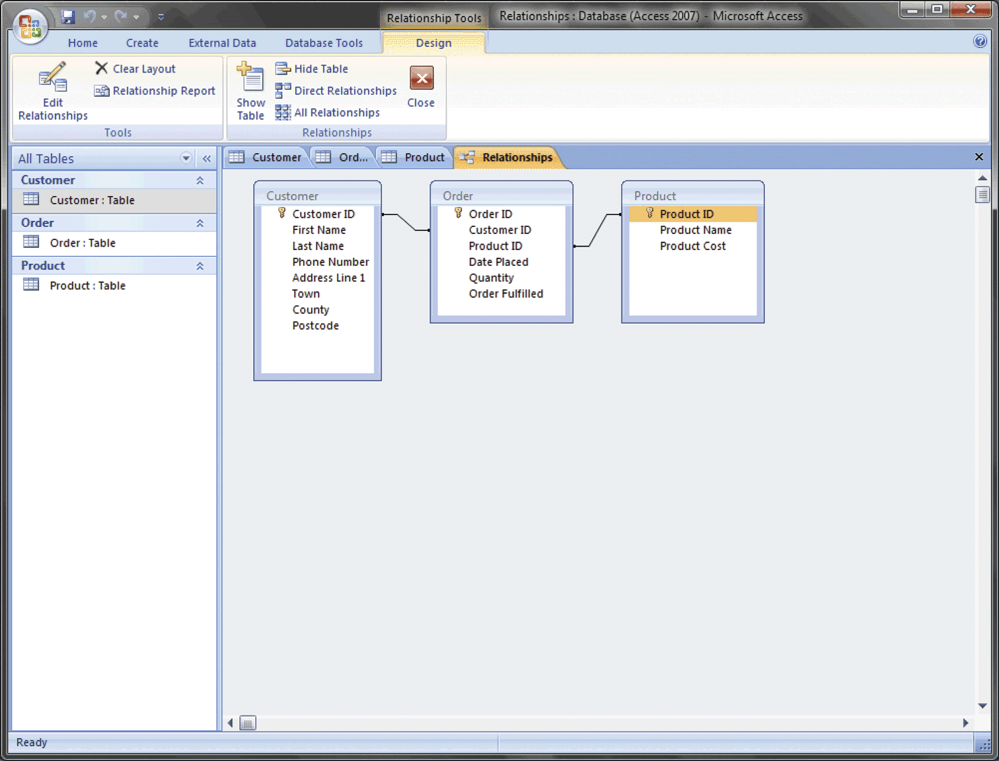

**End Tutorial Seven**

**Topic 8– TUTORIAL-Use Cases**

**1.What is the purpose of producing use cases?**

* **Purpose of producing use cases:**

A use case is a methodology used in system analysis to identify, clarify and organize system requirements. The use case is made up of a set of possible sequences of interactions between systems and users in an environment and related to a particular goal.

2.**Define**

1. **Actor:** An actor is an entity that is a participant in a process, like a person, animal, plant, robot, application, organization, or system. An actor can be internal or external to the system interacting with other entities.
2. **Use Case Description:** Use case is a methodology used in system analysis to identify, clarify, and organize system requirements. The use case is made up of a set of possible sequences of interactions between systems and users in a particular environment and related to a particular goal. The method creates a document that describes all the steps taken by a user to complete an activity.
3. **Pre-Condition:** Pre-condition is a method that must be true at the start of any function for it to act correctly. A hotel must have at least one free room for the period requested.
4. **Post Condition:** Post-condition is a method that will be true for any function finishes its work. The room would have been allocated to the guest for the period requested and is no longer vacant.

**3.Describe in your own words**

* **The difference between the <extend> and <include or uses> relationships in use case diagram:**
* **Extend** is used when a use case conditionally adds steps to another first class use case. For example, imagine "Withdraw Cash" is a use case of an ATM machine. "Assess Fee" would extend Withdraw Cash and describe the conditional "extension point" that is instantiated when the ATM user doesn't bank at the ATM's owning institution. Notice that the basic "Withdraw Cash" use case stands on its own, without the extension.
* **Include** is used to extract use case fragments that are duplicated in multiple use cases. The included use case cannot stand alone, and the original use case is not complete without the included one. This should be used sparingly an only in cases where the duplication is significant and exists by design (rather than by coincidence). For example, the flow of events that occurs at the beginning of every ATM use case (when the user puts in their ATM card, enters their PIN, and is shown the main menu) would be a good candidate for an include.
* **Showing by drawing a Use Case for paying for an item online:**

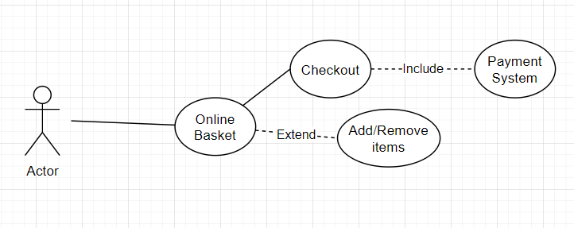

1. Think of the different possible uses you could make of a bank ATM and draw a use case diagram using [www.draw.io](http://www.draw.io) to represent these use cases. E.g., You are withdrawing cash, etc.

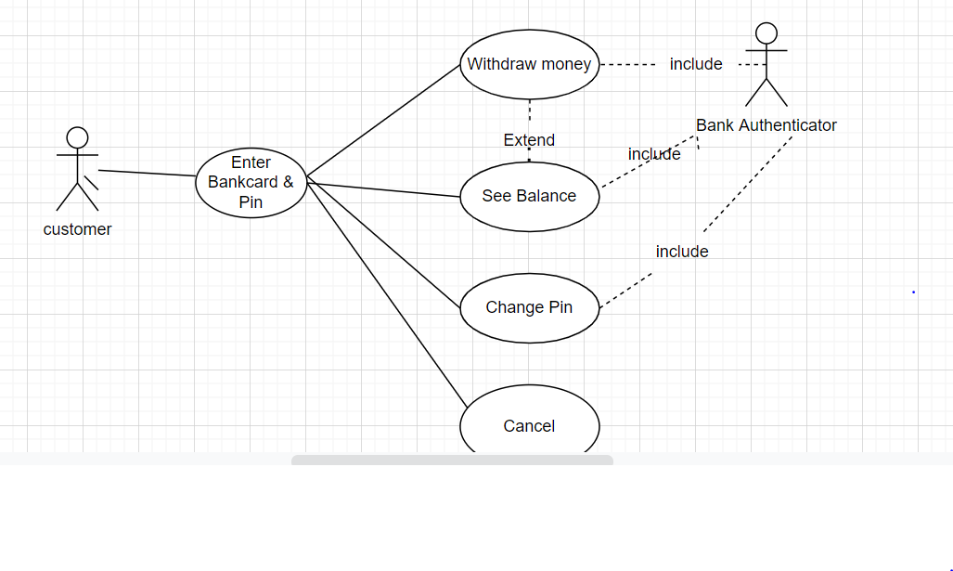

1. Write the use case descriptions for the use cases that you identified in question 4 using the simple template given in the textbook.

|  |  |
| --- | --- |
| Name and Identifier | Customer |
| Initiator | Operator |
| Goal | To withdraw desired amount of cash that customer needed. |
| Pre-condition | The customer must have a valid ATM card and correct PIN. |
| Post-condition | The customer receives the cash amount that he or she wanted to withdraw, with a receipt, if indicated |
| Assumption | The customers account balance is updated in the system. |
|  |  |

1. Start working on your ERD and Use Case for the coursework.

**End Tutorial Eight**

**Topic 9**

**Security – Tutorial**

Q1. **What is Information Security?**

* **Information Security:** Information security is a set of processes and methodologies which are designed and implemented to protect print, electronic or any other form of confidential, private, and sensitive information or data from unauthorized access, use, misuse, disclosure, destruction, modification, or disruption.

Q2. **Highlight the challenges and explain why information security is becoming increasingly. Difficult.**

* **Challenges of Information Security:**
* Phishing Attacks
* Cloud Jacking
* Network Perimeter and Endpoint Security
* Mobile malware
* 5G-to Wi-Fi Security Vulnerabilities
* Internet of Things Devices
* Deepfakes
* High developed Ransomware attacks
* Insider Threats
* API (Application Programming Interface) Vulnerabilities and Breaches
* **Why information security is becoming increasingly difficult:**

There are six significant challenges for which information security becoming increasingly difficult. They are as follows:

• Speed of attacks

• increasing digital information

• Sophistication of attacks

• Faster detection of weaknesses

• Distributed attacks

• Difficulties of patching

Q3. **What are the latest trends in today’s world of cyber security?**

* **Latest Cyber Security trends are as follows:**
* Remote working trend
* Expanding of Internet of Things
* The rise of ransomware
* Increase in cloud services and cloud security threats.
* Smarter Social engineering attacks.
* Data privacy as a discipline.
* Improving of multi-factor authentication.
* Rising of Artificial Intelligence (AI).
* Mobile cyber security becoming front and center

Q4. **Briefly define the following:**

* **Spyware-** Spyware is malicious software designed to enter computer device, gather data, and forward it to third-party without the consent of the user.

There are some common symptoms of spyware to understand, like-

* Difficulty logging into secure websites.
* Random advertisements pop up on device.
* Unusual slowness of system
* Unusual instability like crushes more than usual.
* **Keylogger-** It is a software that documents the key sequence in a log file on a computer that may contain personal email Ids and passwords. The hacker targets this log to get access to such personal information.
* **Rootkits**- Rootkit malware is a collection of software designed to give malicious actors control of a computer network or application.
* **Combined attack mechanism-**

An Attack Mechanism is a system or strategy by which a target is to hit. Combined attack mechanism is special attack system or strategy that consists of two or more characters working as a team attacking at the same time or in rapid succession**.**

* **Mobile Malware**-Mobile Malware is malicious software specially designed to target mobile devices, such as smartphones and tablets, with the goal of gaining access to private data.

**End Tutorial 09**

**Topic 10 – Tutorial Social, Legal and Ethical**

1.What is Hacking? Can it be legal?

* **Hacking:** An attempt to exploit a computer system or a private network inside a computer which is an unauthorized access.
* **When hacking is illegal:** When a hacker tries to breach a system without authorization, it is considered illegal.

Ten thousand of messages from hacked emails were hacked from Clinton campaign chairman John Podestas Gmail account which was illegal hacking.

* **When hacking is legal:** When the hacker is permitted to hack into a system, or a network is legal, and it called **Ethical Hacking.**

A few of them are-Web Application hacking, System Hacking, Web server Hacking.

2.**What is meant by-**

* **Computer monitoring-** The use of computer and communications technology to monitor the activities of individuals. The activities are like, website visited, application use, email, documents movements etc.

3.**What are eight guiding principles of the Data Protection Act?**

* **The eight principals of data protection act:**

1. Fair and lawful
2. Specific for its purpose
3. Be adequate and only for what is needed
4. Accurate and up to date
5. Not kept longer than needed.
6. Take into account people’s rights
7. Kept safe and secure
8. Not be transferred outside the EEA

* **Recently amended six principals and its implications:**

The six GDPR principles are broadly equivalent to the 8 key principles that exist under the Data Protection Act 1998.

The GDPR key principles are:

1.Processing should be lawful, fair and transparent:

2. Personal data shall be collected for specified, explicit and legitimate purposes.

3. Personal data must be adequate, relevant and limited to what is necessary.

4. Personal data shall be accurate and kept up to date.

5. Personal data shall be kept for no longer than is necessary.

6. There must be appropriate security in place in respect of the personal data.

4. **Identify the legislation that covers the following actions:**

a. Distributing a computer virus- Computer Misuse Act 1990

b. Making an unauthorized copy of a computer program- Computer Misuse Act 1990.

c. Gaining unauthorized access to a computer-based information system- Computer Misuse Act 1990.

d. Breaking computer system at UEL out of revenge- Computer Misuse Act 1990.

e. Creating computer virus during lessons and sending to people-Computer Misuse Act 1990.

f. Placing an unauthorized computer program on UEL network system-Computer Misuse Act 1990.

g. Stealing data from UEL accounting file-Computer Misuse Act 1990.

h. Photocopying a software manual-Computer Misuse Act 1990.

5. **What is a professional code of conduct?**

* **Professional code of conduct:**

Members of professional associations are expected to abide by a set of principles that sets out minimum standards of competence, conduct and behavior.

1. **What is reverse engineering?**

* **Reverse Engineering:**

Reverse engineering is the process of dissecting an existing product's constituent parts in order to build a fully replicated design or design knowledge from the data gathered.

1. **What is computer ethics?**

* **Computer Ethics:**

A system of moral rules that governs the use of computers is known as computer ethics.

1. **Can anything be ethical and illegal? Discuss and give examples**

Yes, it can. For example-It may be illegal to break a contract, but it may also be ethical for a variety of reasons. It is illegal to lease a car or an apartment in somebody’s name for someone who would otherwise be unable to qualify, but it is an ethical thing to do if it will help them in achieving their goals.

1. **What can be unethical and legal? Give five examples.**

Breaking promises is legal in most cases, although it is commonly regarded as unethical. Cheating on friend is legal, but it is unethical.

**End Tutorial Ten**